**Insert School Logo**

**Semester One**

**Examination 2024**

**Question/Answer Booklet**

**Physical Education Studies**

**Units 1&2**

Name: _______________________________________________________

Teacher: ___________________________________________________

***TIME ALLOWED FOR THIS PAPER***

Reading time before commencing work: Ten minutes

Working time for the paper: Two and half hours

***MATERIALS REQUIRED/RECOMMENDED FOR THIS PAPER***

**To be provided by the supervisor:**

* This Question/Answer Booklet

**To be provided by the candidate:**

* Standard items: pens, pencils, eraser or correction fluid, ruler, highlighter.
* Special items: Calculators satisfying the conditions set by the SCSA for this subject.

***IMPORTANT NOTE TO CANDIDATES***

No other items may be taken into the examination room. It is **your** responsibility to ensure that you do not have any unauthorised notes or other items of a non-personal nature in the examination room. If you have any unauthorised material with you, hand it to the supervisor **before** reading any further.

**Structure of this paper**

|  |  |  |  |  |  |
| --- | --- | --- | --- | --- | --- |
| Section | Number of questions available | Number of questions to be answered | Suggested working time  (minutes) | Marks available | Percentage of exam |
| Topic One:  Multiple Choice | x | x | 30 | x | 20 |
| Section Two:  Short answer | x | x | 70 | x | 50 |
| Section Three:  Extended answer | x | x | 50 | x | 30 |
|  |  |  | **Total** | x | 100 |

**Instructions to candidates**

1. The rules for the conduct of Western Australian external examinations are detailed in the *Year 11 Information Handbook 2017.* Sitting this examination implies that you agree to abide by these rules.
2. Write your answers in this Question/Answer Booklet.

Answer all questions according to the following instructions.

Multiple-Choice: Answer **all** questions on the separate Multiple-choice Answer Sheet provided. For each question shade the box to indicate your answer. Use only a blue or black pen to shade the boxes. If you make a mistake, place a cross through that square, do not erase or use correction fluid, and shade your new answer. Marks will not be deducted for incorrect answers. No mark will be given if more than one answer is completed for any reason.

Short Answer and Extended Answer: Write answers to in this Question/Answer Booklet.

1. You must be careful to confine your responses to the specific questions asked and follow any instructions that are specific to a particular question.
2. Spare pages are included at the end of this booklet. They can be used for planning your responses and/or as additional space if required to continue an answer.
   * Planning: If you use the spare pages for planning, indicate this clearly.
   * Continuing an answer: If you need to use the space to continue an answer, indicate in the original answer space where the answer is continued, i.e. give the page number. Refer to the question(s) where you are continuing your work.

**Topic: Functional Anatomy (35 marks)**

This section has **10** questions. Answer **all** questions. Answer the five **(5)** Multiple-Choice questions on the separate Multiple-choice answer Sheet provided. Write your answers to the Short Answer and Extended Answer question in the spaces provided in this Question/Answer Booklet. Wherever possible, confine your answers to the line spaces provided. Use a blue or black pen (**not** pencil) for this section.

Spare pages are included at the end of this booklet. They can be used for planning your responses and/or as additional space if required to continue an answer.

Suggested working time: 50 minutes.

**Multiple Choice (5 marks)**

1. Alveoli air sacs where oxygen is diffused are found at the end of the
2. capillaries.
3. bronchioles.
4. trachea.
5. lungs.
6. The agonist is a muscle which is
7. lengthening.
8. contracting.
9. stabilising.
10. voluntary.
11. Which blood vessel carries oxygenated blood to the heart?
12. vena cava
13. aorta
14. pulmonary vein
15. capillaries
16. The origin point for the quadriceps muscle is located on the
17. tibia.
18. femur.
19. patella.
20. pelvis.

5. Moving the arms outwards to catch and pull during breaststroke swimming would be described as

1. abduction.
2. flexion.
3. extension.
4. adduction.

**Short Answer (20 marks)**

**Question 6 (5 marks)**

Describe the mechanics of inhalation when breathing during swimming.

___________________

___________________

___________________

___________________

___________________

___________________

___________________

___________________

___________________

___________________

___________________

**Question 7 (4 marks)**

Capillaries are only one cell thick to allow for their efficient function of diffusion of oxygen and carbon dioxide. Outline **two (2)** characteristics of arteries and veins that enable them to function appropriately.

___________________

___________________

___________________

___________________

___________________

___________________

___________________

___________________

**Question 8 (4 marks)**

Label the **four (4)** bones of the leg indicated in the diagram below:

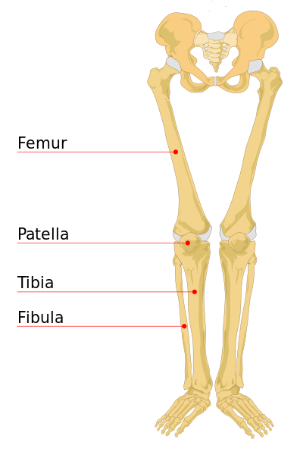

**Question 9 (7 marks)**

Muscles which work together are known as antagonistic pairs.

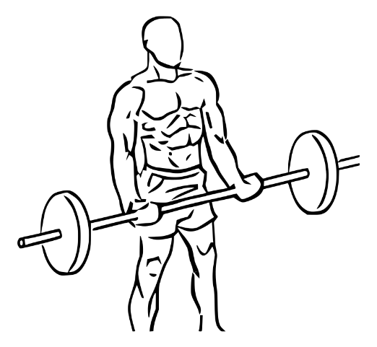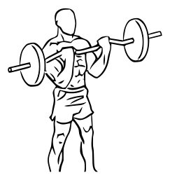

(a) When completing a bicep curl, identify and describe how muscles work in pairs to lift and lower the barbell.

(4 marks)

___________________

___________________

___________________

___________________

___________________

___________________

___________________

___________________

(b) Outline the types of movement at the elbow during the bicep curl. (2 marks)

___________________

___________________

___________________

___________________

(c) Define excitability in relation to the characteristic of skeletal muscle during the bicep curl.

(1 mark)

___________________

___________________

**Extended Answer (10 marks)**

**Question 10 (10 marks)**

Mathieu van der Poel is an outstanding cyclist having won the World Cyclo-Cross Championship on five occasions. His aerobic capacity allowed him to make a seamless transition to road cycling, where he won the World Road Race Championship in 2023 across a distance of 273km over 6 hours. Explain how oxygen enters the circulatory system and the pathway it takes to Mathieu’s working muscles and then the pathway to removing carbon dioxide from the lungs.

(10 marks)

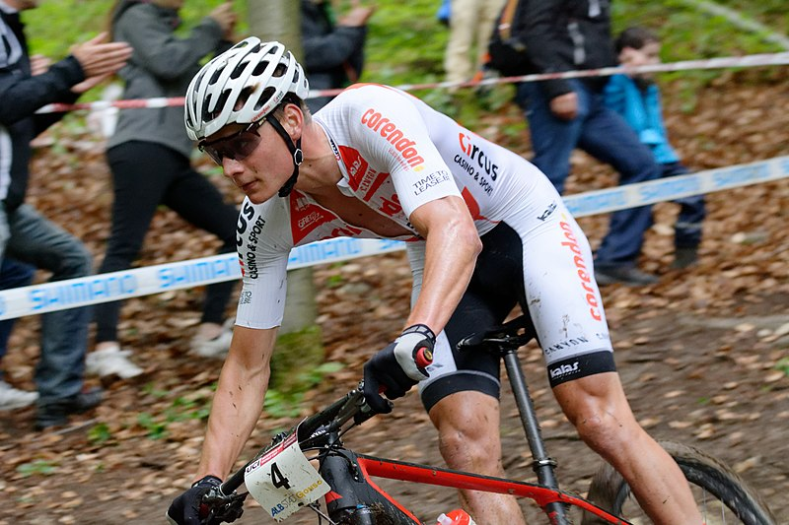

___________________

___________________

___________________

___________________

___________________

___________________

___________________

___________________

___________________

___________________

___________________

___________________

___________________

___________________

___________________

___________________

___________________

___________________

___________________

___________________

___________________

___________________

___________________

___________________

___________________

___________________

___________________

___________________

___________________

___________________

___________________

___________________

___________________

___________________

___________________

___________________

___________________

___________________

___________________

**End of Topic**

**Topic: Exercise Physiology (35 marks)**

This section has **9** questions. Answer **all** questions. Answer the five **(5)** Multiple-Choice questions on the separate Multiple-choice answer Sheet provided. Write your answers to the Short Answer and Extended Answer question in the spaces provided in this Question/Answer Booklet. Wherever possible, confine your answers to the line spaces provided. Use a blue or black pen (**not** pencil) for this section.

Spare pages are included at the end of this booklet. They can be used for planning your responses and/or as additional space if required to continue an answer.

Suggested working time: 50 minutes.

**Multiple Choice (5 marks)**

* + - 1. What is a muscular contraction known as when muscle length remains constant or the same during contraction?
         1. isotonic
         2. isokinetic
         3. insertion
         4. isometric
      2. Which of the following would be an acute response to continuous training?

1. increased capillarisation
2. increased heart rate
3. decreased blood pressure
4. decreased ventilation rate
   * + 1. The predominant energy system utilised during a one-minute, 400m in athletics would be the
5. lactic acid system.
6. ATP-CP system.
7. aerobic system.
8. inter-play of all three energy systems.
   * + 1. Weightlifters would be best coached towards which main method of training?
9. flexibility training
10. continuous training
11. plyometrics
12. resistance training
    * + 1. When compiling a training program, which component of fitness would be of most importance to a cross country skier?
           1. muscular endurance
           2. balance
           3. speed
           4. muscular strength

**Short Answer (20 marks)**

**Question 6 (6 marks)**

Different sports require specific components of fitness based upon the demands placed on the physiological systems of the body. Complete the table below:

|  |  |  |
| --- | --- | --- |
| **Component of Fitness** | **Definition** | **Sporting Example** |
| Flexibility |  | Gymnastic splits |
|  | Being able to change direction quickly and accurately in a confined area. |  |
| Balance |  | Ice skater |
|  |  | 100m sprint start |

**Question 7 (4 marks)**

Training programmes should incorporate specificity and progressive overload to place stress upon the athlete’s physiological systems, causing adaptations. Outline **two (2)** principles that any athlete can adjust as they adapt.

___________________

___________________

___________________

___________________

___________________

___________________

___________________

___________________

___________________

___________________

**Question 8 (10 marks)**

Richard is completing a 6-week training programme leading up to the National Cross Country Championships where he will compete over a 12km course in approximately 40 minutes.

(a) Identify the predominant energy system and component of fitness when competing in cross country.

(2 marks)

___________________

___________________

___________________

___________________

(b) List **two (2)** training types that Richard would predominantly incorporate in his training programme.

(2 marks)

___________________

___________________

___________________

(c) Using your understanding of the chronic adaptations to training, describe **three (3)** effects of training on the circulatory system.

(6 marks)

___________________

___________________

___________________

___________________

___________________

___________________

___________________

___________________

___________________

___________________

___________________

**Extended Answer (10 marks)**

**Question 9 (10 marks)**

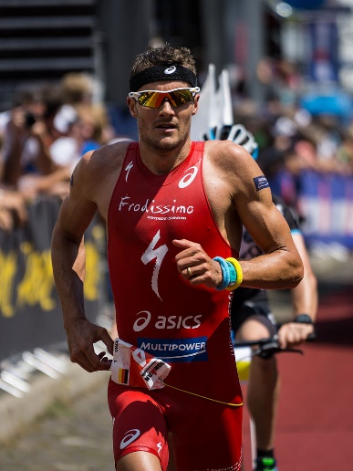The Busselton Ironman Triathlon consists of a 3.8km open water swim, 180km cycle and 42.2km run. Elite athletes can complete the course in 8 hours, whilst amateurs can take up to 16 hours to cross the finish line.

Explain how an ironman triathlete will nutritionally fuel and hydrate themselves prior and during the race to optimise their performance.

(10 marks)

___________________

___________________

___________________

___________________

___________________

___________________

___________________

___________________

___________________

___________________

___________________

___________________

___________________

___________________

___________________

___________________

___________________

___________________

___________________

___________________

___________________

___________________

___________________

___________________

___________________

___________________

___________________

___________________

___________________

___________________

___________________

___________________

___________________

___________________

___________________

___________________

___________________

___________________

___________________

___________________

**End of Topic**

**Topic: Biomechanics (35 marks)**

This section has **9** questions. Answer **all** questions. Answer the five **(5)** Multiple-Choice questions on the separate Multiple-choice answer Sheet provided. Write your answers to the Short Answer and Extended Answer question in the spaces provided in this Question/Answer Booklet. Wherever possible, confine your answers to the line spaces provided. Use a blue or black pen (**not** pencil) for this section.

Spare pages are included at the end of this booklet. They can be used for planning your responses and/or as additional space if required to continue an answer.

Suggested working time: 50 minutes.

**Multiple Choice (5 marks)**

1. Maintaining the position shown in the photo below, a downhill skier would be best described as having which type of motion?

1. general motion
2. linear motion
3. angular motion
4. projectile motion
5. Displacement represents which of the following?
6. the change in athlete’s position from the start to finish point
7. how far an athlete travels from the start to finish point
8. the athlete’s rate of acceleration between the start and finish point
9. the maximal velocity the athlete achieves between the start and finish point
10. When serving in Tennis, the player is aiming for the ball to accelerate as fast as possible. Which of Newton’s Laws of Motion is this applicable to?
11. Newton’s First Law of Motion
12. Newton’s Second Law of Motion
13. Newton’s Third Law of Motion
14. Newton’s Fourth Law of Motion

4. Bobsleigh requires a maximal acceleration to propel the sleigh to maximal velocity. Acceleration can best be described as the

1. amount of motion possessed by a moving body.
2. velocity an object travels in a particular direction.
3. change in velocity of an object every second.
4. force it takes to move an object.

5. In Sumo Wrestling, the aim is to destabilise their opponent in order to gain an advantage.

Which of the following statements would apply to Sumo Wrestlers when attempting to decrease the equilibrium of their opponent?

1. decreasing the size of base of support
2. increasing the mass of the body
3. raising the centre of mass
4. reducing the points of contact
5. ensuring the line of gravity is within the base of support
6. ii, iii, iv, v
7. i, iii, iv
8. iii, iv, v
9. ii, v

**Short Answer (20 marks)**

**Question 6 (10 marks)**

Sprinters must ensure that they control their balance to avoid a false start, yet also have the greatest possible acceleration from the blocks.

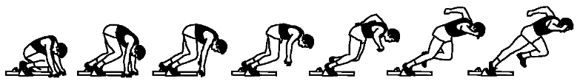(a) Identify and define the **two (2)** types of balance that the sprinter must demonstrate at the start.

(4 marks)

___________________

___________________

___________________

___________________

___________________

___________________

(b) The greater the mass of the sprinter, the greater their stability. Describe how **three (3)** other principles of balance change during the sprint start sequence pictured above.

(6 marks)

___________________

___________________

___________________

___________________

___________________

___________________

___________________

___________________

___________________

___________________

___________________

___________________

**Question 7 (4 marks)**

Preparation of the neck when heading in soccer is important to generate a forceful impact upon the ball.

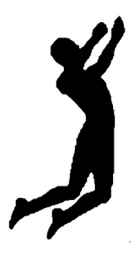

* + - * 1. Using your understanding of levers, label the components of the lever shown during the preparation phase of heading a soccer ball:

(3 marks)

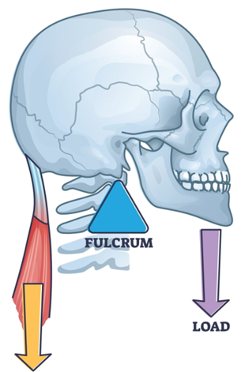

* + - * 1. Identify the class of lever you have labelled. (1 mark)

___________________

**Question 8 (6 marks)**

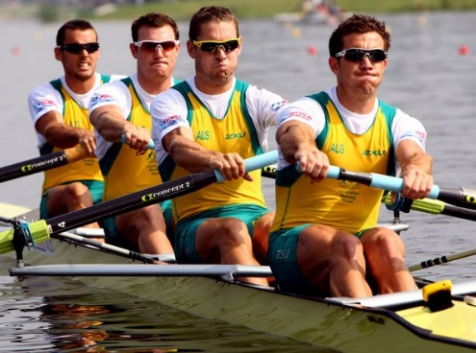Rowing requires the athletes to cover a 2km course from start to finish in a straight line as fast as possible.

Define **three (3)** types of motion providing an example of each for the rowers pictured. (6 marks)

___________________

___________________

___________________

___________________

___________________

___________________

___________________

___________________

___________________

___________________

___________________

___________________

**Extended Answer (10 marks)**

**Question 9 (10 marks)**

Golf requires both force and precision for the shot to be accurate and the ball to land as close to the hole or ‘pin’ as possible.

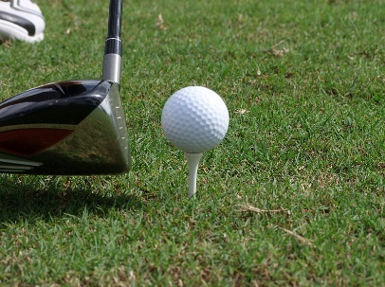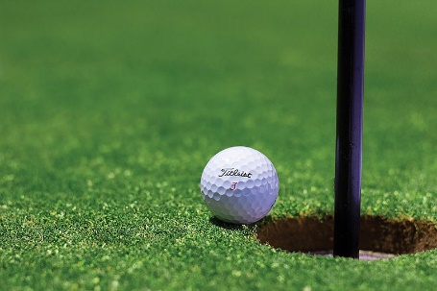

(a) Explain how Newton’s 1st and 2nd Law of Motion are applied by golfers to achieve the most accurate shot as possible.

(6 marks)

___________________

___________________

___________________

___________________

___________________

___________________

___________________

___________________

___________________

___________________

___________________

___________________

___________________

___________________

___________________

___________________

Elevated holes or ‘pins’ are often included as part of the golf course contours to increase difficulty. Golfers must consider the optimal trajectory or flight path of the ball in order to ensure accuracy.

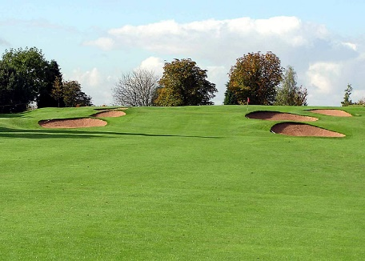

Elevated hole or ‘Pin’

(b) In relation to projectile motion, describe how a golfer will adjust their shot to gain optimal accuracy for an elevated hole or ‘pin’ for the following factors:

* Angle of Release
* Velocity of Release (4 marks)

___________________

___________________

___________________

___________________

___________________

___________________

___________________

___________________

___________________

___________________

___________________

___________________

**End of Topic**

**Topic: Sports Psychology (35 marks)**

This section has **10** questions. Answer **all** questions. Answer the five **(5)** Multiple-Choice questions on the separate Multiple-choice answer Sheet provided. Write your answers to the Short Answer and Extended Answer question in the spaces provided in this Question/Answer Booklet. Wherever possible, confine your answers to the line spaces provided. Use a blue or black pen (**not** pencil) for this section.

Spare pages are included at the end of this booklet. They can be used for planning your responses and/or as additional space if required to continue an answer.

Suggested working time: 50 minutes.

**Multiple Choice (5 marks)**

* + - 1. Using selective attention to focus upon relevant stimuli during a golf tee off shot would benefit performance by
  1. increasing arousal.
  2. increasing self-confidence.
  3. improving concentration.
  4. reducing stress.
     + 1. Which of the following statements about arousal is correct?

1. weightlifting requires a low level of arousal for optimal performance
2. novice performers require a high level of arousal for optimal performance
3. golf putting requires a low level of arousal for optimal performance
4. gymnastics beam requires a high level of arousal for optimal performance
   * + 1. An Australian Football player must try to ‘block-out’ irrelevant cues or distractions when kicking for goal to increase success. The players attentional focus is
5. narrow and internal.
6. narrow and external.
7. broad and internal.
8. broad and external.
   * + 1. Joe sets himself a goal to reduce his 1500m time by 3 seconds per week over a 4 week training programme to achieve a personal best at his Inter-School Athletics Carnival. What type of goal is this?
9. personal goal
10. performance goal
11. outcome goal
12. process goal
    * + 1. Motivation for involvement in physical activity can be influenced by which of the following?
13. age, stress and type of activity
14. age, skill level and self-confidence
15. age, skill level and arousal regulation
16. age, skill level and type of activity

**Short Answer (20 marks)**

**Question 6 (3 marks)**

Psychological arousal regulation is important for all sporting competitions. Label the Inverted U hypothesis graph below.

(3 marks)

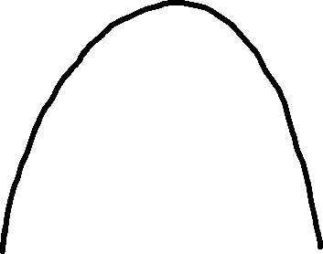

Arousal

**Question 7 (4 marks)**

Michael Jordan was famous for consistently making game winning shots under pressure. When interviewed, he always commented that he was confident in his ability to successfully make the ‘clutch’ shot and always thought his game winning shots would be successful.

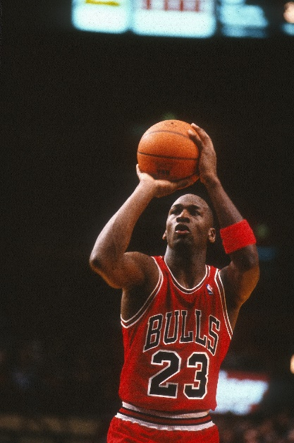

(a) Define self-confidence. (1 mark)

___________________

___________________

___________________

(b) Michael Jordan was often described as being ‘in the zone’. List **three (3)** possible psychological relaxation strategies that any athlete may choose to utilise to optimise their performance for success.

(3 marks)

___________________

___________________

___________________

___________________

**Question 8 (9 marks)**

Agreeing on a realistic goal with your coach for a forthcoming Inter-School Cross Country race can positively affect motivation to help achieve a personal best time.

(a) List **five (5)** other characteristics of effective goal setting. (5 marks)

___________________

___________________

___________________

___________________

___________________

(b) Maintaining motivation during a training programme can be challenging; however, setting realistic performance and outcome goals can raise motivation. Outline performance and outcome goals and provide a possible example for an Inter-School Cross Country race.

(4 marks)

___________________

___________________

___________________

___________________

___________________

___________________

___________________

___________________

**Question 9 (4 marks)**

Motivation is an important factor in the pathway to achieve long term goals. Describe the **two (2)** types of motivation and provide a sporting example for each.

(4 marks)

___________________

___________________

___________________

___________________

___________________

___________________

___________________

___________________

**Extended Answer (10 marks)**

**Question 10 (10 marks)**

Nideffer’s Model of Attentional Control indicates that different sports and skills require varying attentional demands across the dimensions of direction and width. Optimal focus must be directed appropriately.

(a) Label the **four (4)** attentional factors of the direction and width dimensions on the diagram below.

(4 marks)

**Direction**

**Width**

**1.**

___________________

___________________

___________________

___________________

**2.**

___________________

___________________

___________________

___________________

(b) Identify a specific sporting skill of choice at points **1.** and **2.** indicated on the graph above relevant to the labelled attentional focus and dimensions axis.

(2 marks)

(c) Justify your choices for the specific skills chosen, outlining the sporting context and attentional requirements.

(4 marks)

___________________

___________________

___________________

___________________

___________________

___________________

___________________

___________________

___________________

___________________

___________________

___________________

___________________

___________________

___________________

___________________

**End of Topic**

**Topic: Motor Learning & Coaching (35 marks)**

This section has **9** questions. Answer **all** questions. Answer the five **(5)** Multiple-Choice questions on the separate Multiple-choice answer Sheet provided. Write your answers to the Short Answer and Extended Answer question in the spaces provided in this Question/Answer Booklet. Wherever possible, confine your answers to the line spaces provided. Use a blue or black pen (**not** pencil) for this section.

Spare pages are included at the end of this booklet. They can be used for planning your responses and/or as additional space if required to continue an answer.

Suggested working time: 50 minutes.

**Multiple Choice (5 marks)**

* + 1. Feedback provided to a basketball team from their coach on the sideline during play would be classified as

1. terminal.
2. concurrent.
3. distracting.
4. positive.
   * 1. Triple Jump would be best classified as a
5. fine skill.
6. open skill.
7. continuous skill.
8. serial skill.
   * 1. A Year 11 student achieving a personal best in their Inter-House 50m Freestyle Swimming event would be classified as which type of feedback?
9. knowledge of performance
10. knowledge of result
11. concurrent
12. positive
    * 1. Which of the following is an example of an athlete utilising proprioception to improve performance?
13. gymnast contracting their muscles to push off when vaulting
14. swimmer adjusting their hand position to feel the catch of the water
15. netball player changing direction to evade a defender
16. golfer changing their choice of club after looking at the distance of the pin (hole)
    * 1. Which of the following are the purposes of feedback?
         + 1. reinforcement of correct skill execution
           2. modification of future performance
           3. increase motivation
           4. all of the above

**Short Answer (20 marks)**

**Question 6 (7 marks)**

Past Chicago Bulls coach Phil Jackson was known for providing elite basketball players effective and timely feedback before, during and after skill execution to improve performance in the future.

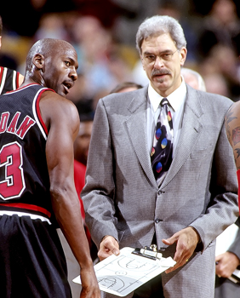

(a) Identify **two (2)** types of extrinsic or augmented feedback. (2 marks)

___________________

___________________

___________________

___________________

(b) Outline intrinsic feedback providing a sporting example. (3 marks)

___________________

___________________

___________________

___________________

___________________

___________________

(c) A coach can provide proprioceptive cues to improve future performance. Identify **two (2)** other cues a coach can utilise to help sports people.

(2 marks)

___________________

___________________

___________________

___________________

**Question 7 (7 marks)**

The Fitts and Posner Motor Learning Model provides the characteristics of performance within each phase of learning.

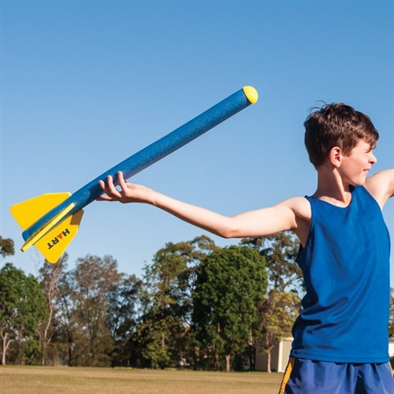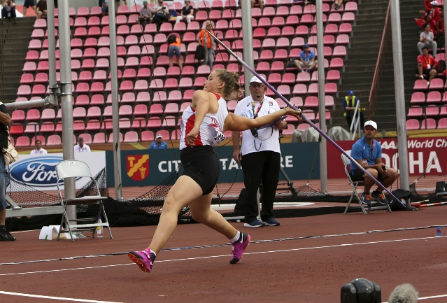

**Image A Image B**

(a) Identify the phases of learning shown in the images. (2 marks)

**Image A:**  ________________________________________________

**Image B:**  ____________ ___________________

(b) Describe **two (2)** of the skill characteristics that you would expect for each of the images.

(4 marks)

___________________

___________________

___________________

___________________

___________________

___________________

___________________

___________________

(c) Identify the longest phase of learning. (1 mark)

___________________

**Question 8 (6 marks)**

Archery can be classified as a skill by the characteristics it exhibits.

(a) Using a circle, clearly classify archery on the skill continuums below. (3 marks)

(b) Justify your reason for the classification chosen under the continuum. (3 marks)

**Fine**

**Gross**

___________________

___________________

___________________

___________________

**Serial**

**Continuous**

**Discrete**

___________________

___________________

___________________

___________________

**Open**

**Closed**

___________________

___________________

___________________

___________________

**Extended Answer (10 marks)**

**Question 9 (10 marks)**

Being an unexpected tenth penalty taker, Cortnee Vine controlled her nerves to score the winning penalty against France in the World Cup Quarter-Final to win 7-6 in the shootout in 2023!

(a) Complete the following flow chart that outlines each stage of the Information Processing Model.

(6 marks)

**Input**

______________________________

______________________________

______________________________

______________________________

______________________________

**________________**

______________________________

______________________________

______________________________

______________________________

______________________________

**Output**

______________________________

______________________________

______________________________

______________________________

______________________________

**­­­­­­­­­­­­­________________**

______________________________

______________________________

______________________________

______________________________

______________________________

(b) Outline a specific example of each stage of the Information Processing Model to Cortnee Vine’s winning penalty.

(4 marks)

___________________

___________________

___________________

___________________

___________________

___________________

___________________

___________________

___________________

___________________

___________________

___________________

**End of Topic**

**Additional working space**

Question number(s): ……………………

**Additional working space**

Question number(s): ……………………

**ACKNOWLEDGEMENTS**

**Functional Anatomy**

Question 8

Image of leg bones

[**https://commons.wikimedia.org/wiki/File:Human_leg_bones_labeled.svg**](https://commons.wikimedia.org/wiki/File:Human_leg_bones_labeled.svg)

Question 9

Image of bicep barbell curl

[**https://commons.wikimedia.org/wiki/File:Bicep_curls_with_barbell_1.svg**](https://commons.wikimedia.org/wiki/File:Bicep_curls_with_barbell_1.svg)

[**https://en.wikipedia.org/wiki/Bicep_curl**](https://en.wikipedia.org/wiki/Bicep_curl)

Question 10

Image of Mathieu van der Poel

[**https://commons.wikimedia.org/wiki/File:Mathieu_van_der_Poel_Albstadt_2018.jpg**](https://commons.wikimedia.org/wiki/File:Mathieu_van_der_Poel_Albstadt_2018.jpg)

**Exercise Physiology**

Question 9

Image of triathlete Jan Frodeno

[**https://commons.wikimedia.org/wiki/Category:Jan_Frodeno**](https://commons.wikimedia.org/wiki/Category:Jan_Frodeno)

**Biomechanics**

Question 1

Image of downhill skier

[**https://commons.wikimedia.org/wiki/File:Andrej_%C5%A0porn_at_the_2010_Winter_Olympic_downhill.jpg**](https://commons.wikimedia.org/wiki/File:Andrej_%C5%A0porn_at_the_2010_Winter_Olympic_downhill.jpg)

Question 5

Image of Sumo wrestling

[**https://commons.wikimedia.org/wiki/File:Sumo_Wrestling_-_Tokyo_%28cropped%29.jpg**](https://commons.wikimedia.org/wiki/File:Sumo_Wrestling_-_Tokyo_%28cropped%29.jpg)

Question 6

Image of sprint start sequence

[**https://www.semanticscholar.org/paper/The-effect-of-muscular-pre-tensing-on-the-sprint-Guti%C3%A9rrez-D%C3%A1villa-Dapena/1e04d629eeaf70b0a01e28556e6ac5fb08dff129**](https://www.semanticscholar.org/paper/The-effect-of-muscular-pre-tensing-on-the-sprint-Guti%C3%A9rrez-D%C3%A1villa-Dapena/1e04d629eeaf70b0a01e28556e6ac5fb08dff129)

Question 7

Image of soccer heading

**<https://www.mdpi.com/2076-3417/12/21/10886>**

Question 7

Image of 1st class lever

[**https://www.shutterstock.com/image-vector/lever-systems-human-body-neck-leg-2187989347**](https://aus01.safelinks.protection.outlook.com/?url=https%3A%2F%2Fwww.shutterstock.com%2Fimage-vector%2Flever-systems-human-body-neck-leg-2187989347&data=05%7C01%7Cbstreeter%40pmacs.wa.edu.au%7Cce0714789d0e4e37833608dbb4c15e19%7Cfaa5dde3cbf548e0bf3334e2cedfcd6c%7C0%7C0%7C638302514847818722%7CUnknown%7CTWFpbGZsb3d8eyJWIjoiMC4wLjAwMDAiLCJQIjoiV2luMzIiLCJBTiI6Ik1haWwiLCJXVCI6Mn0%3D%7C3000%7C%7C%7C&sdata=UfOdTBokjBn2t0K5EyE%2FSkxHFd5FGMI0CVG2n6I9z3I%3D&reserved=0)

Question 8

Image of rowers

[**https://www.wikiwand.com/en/Matt_Ryan_(rower)**](https://www.wikiwand.com/en/Matt_Ryan_(rower))

Question 9

Image of golf ball on tee

[**https://commons.wikimedia.org/wiki/File:Golf_ball_on_tee.jpg**](https://commons.wikimedia.org/wiki/File:Golf_ball_on_tee.jpg)

Question 9

Image of golf ball near hole

[**https://commons.wikimedia.org/wiki/File:Ball_Near_Golf_Hole.jpg**](https://commons.wikimedia.org/wiki/File:Ball_Near_Golf_Hole.jpg)

Question 9

Image of elevated golf pin

[**https://commons.wikimedia.org/wiki/File:Golf_bunkers_Filton.jpg**](https://commons.wikimedia.org/wiki/File:Golf_bunkers_Filton.jpg)

**Sports Psychology**

Question 7

Image of Michael Jordan

[**https://www.dreamstime.com/michael-jordan-chicago-bulls-game-action-regular-season-image212463578**](https://www.dreamstime.com/michael-jordan-chicago-bulls-game-action-regular-season-image212463578)

**Motor Learning & Coaching**

Question 6

Image of Phil Jackson

[**https://commons.wikimedia.org/wiki/File:Phil_Jackson_Lipofsky.JPG**](https://commons.wikimedia.org/wiki/File:Phil_Jackson_Lipofsky.JPG)

Question 7

Image of turbo javelin

[**https://www.hartsport.com.au/hart-foam-javelin-long**](https://www.hartsport.com.au/hart-foam-javelin-long)

Question 7

Image of javelin thrower

[**https://www.dreamstime.com/tampere-finland-july-munevver-hanci-turkey-javelin-throw-event-iaaf-world-u-championship-image135853107**](https://www.dreamstime.com/tampere-finland-july-munevver-hanci-turkey-javelin-throw-event-iaaf-world-u-championship-image135853107)

Question 8

Image of archery

[**https://commons.wikimedia.org/wiki/File:WA_target_shot_with_a_compound_bow_%28Devizes_Bowmen%29.jpg**](https://commons.wikimedia.org/wiki/File:WA_target_shot_with_a_compound_bow_%28Devizes_Bowmen%29.jpg)

WATP acknowledges the permission of the School Curriculum and Standards Authority in providing instructions to students.